**Toboganes y escaleras**

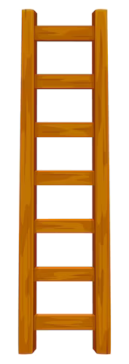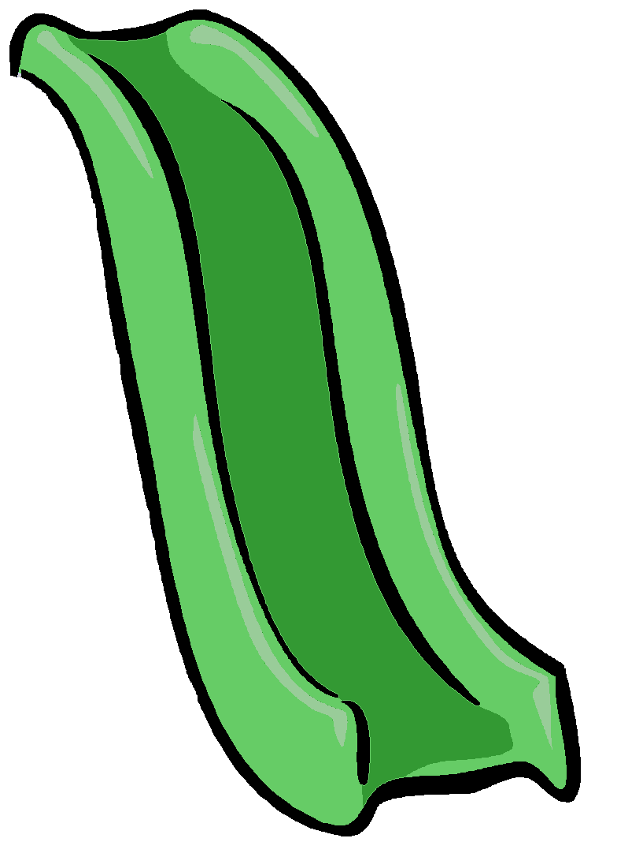

|  |  |  |  |  |  |  |  |  | **Fin** |
| --- | --- | --- | --- | --- | --- | --- | --- | --- | --- |
|  |  |  |  |  |  |  |  |  |  |
|  |  |  |  |  |  |  |  |  |  |
|  |  |  |  |  |  |  |  |  |  |
| **Inicio** |  |  |  |  |  |  |  |  |  |

